## 2025-2026 McBean Calendar

**August**

7/31 Open House

Building Staff Capacity Training

**September: Attendance Awareness Month**

9/2 Power Up Asynchronous Learning

9/15 Fall Conferences Begin

9/24 Annual Title I Meeting

**October:** Drug Awareness Month

10/10 Fall Conferences End

10/10 PowerUp Asynchronous Learning

10/13-14 Fall Break

Building Staff Capacity Training

Building Parent Capacity Training

Red Ribbon Week

Bully Prevention and Safety Training

10/25 Fall Carnival

**November**

School Council Meeting

11/17-11/21 American Education Week

**December**

1st Semester Attendance Party

12/20 End of 1st Semester

**January**

1/6 Start of 2nd Semester

100th Day of School

**February**

Feb 12 – Progress Report

Feb 13-16 – Student Holiday

Feb 17- Spring Parent Conference window

**March**

3/16 Parent conference window ends

3/27 Progress Report

**April**

4/3 Power Up Asynchronous Learning Day

4/6-13 Spring Break

**May**

Honor’s Day

Field Day

I-Ready Growth Party

Attendance Party

5/22 Last Day of School Early Release

**\*Additional Dates to Come! Parents will be notified about any changes in advance. \***



#### “Where We PAWS for Excellence”

**School-Parent Compact**

**2025-2026**

McBean Elementary School

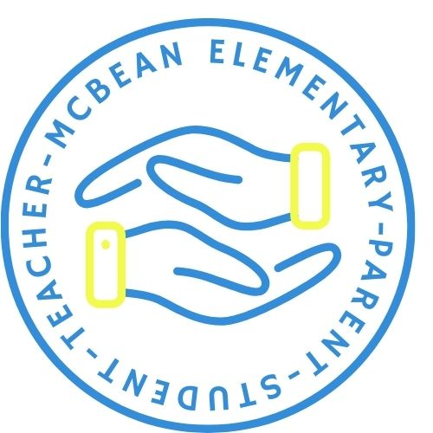



Sheri Calhoun

Principal

Katrina Prophet

Assistant Principal

**The Purpose and Benefit of this Compact**

The purpose of this compact is to ensure effective engagement of parents and to support a partnership between our school, parents and the community to improve student academic success.

**Communication about Student Learning**

McBean Elementary School is committed to two-way communication with families about children’s learning. We embrace an open-door policy. Other ways you can expect us to reach you are: Weekly homework folders, updates on the school website, Infinite Campus Parent Portal, Parent-teacher conferences, Facebook page, Class Dojo/Remind, Letters/Email/Flyers, Quarterly Newsletter, Conferences and PTO. McBean has access to translators and will provide full opportunity for parents with limited English, disabilities, and migrant children. All flyers and information will be available in a language most understood by parents.

**Jointly Developed**

The parents, students, and staff worked together to share ideas to develop the school-parent compact. Academic goals have been set based on school data, as well as students, faculty and staff feedback. Stakeholders, parents, and students provided feedback with Title I surveys on their needs and strategies they are willing to work on with the school. Meetings are held each school year and feedback is welcomed in the front office.

Sheri Calhoun- Principal

calhosh@boe.richmond.k12.ga.us

Krishell Motley- Parent Facilitator Designee

motlekr@boe.richmond.k12.ga.us

Revised: May 5, 2025

1165 Hephzibah-McBean Rd.

Hephzibah, GA 30815

706.592.3723

# District Goals:

The system goals are…

**Student Achievement**

* During the 25-26 school year, we will increase student content mastery in tested subject areas on the Georgia Milestones by 6%.
* During the 25-26 school year, we will increase post-high school readiness by increasing our graduation rate by 2%.

**Talent Development**

* During 25-26, we will increase teacher and support staff retention by 3% through consistent, meaningful employee feedback and evaluations.

**Safe & Secure Learning Environment**

* During the 25-26 school year, we will reduce chronic absenteeism by 3%.
* During the 25-26 school year, we will improve the on-time delivery rate of student transportation services by 5%.

**McBean Goals for 2025-2026:**

* By May 2026, we will decrease the number of students missing 10 or more days of school by 6%.
* By May 2026, we will increase i-Ready reading scores by 6% from 56% to 62% proficiency through rigorous and engaging instruction.
* By May 2026, we will increase i-Ready math scores by 6 from 51% to 57% proficiency through rigorous and engaging instruction.

**Content Area Focus for Improvement:**

**K-5 English Language Arts:**

* Implement school-wide reading initiatives using Accelerated Reading and Book-It to support students in grades Pre-K through 5th.
* Model instructional expectations for reading focusing on increasing rigor and adding acceleration to tier 1 instruction.
* Conduct peer observations to promote reflection, collaboration, and improvement of teacher pedagogy.

**K-5 Mathematics:**

* Provide professional learning on Number Talks in grades K-5.
* Implement small groups and stations with the usage of manipulatives and digital learning opportunities.
* Implement the use of GADOE Inspire lessons.
* Conduct Math Night/Building Parent Capacity Sessions to provide parents with strategies to support their child(ren)'s acquisition and practice with math skills.

**McBean Attendance:**

* Utilize the District Attendance Protocol to connect students/parents to resources in an effort to avoid significant loss of instruction.
* Teachers will contact parents/guardians of an absent student following each absence and log it into Infinite Campus.
* Incentivize attendance by providing opportunities for positive recognition of students monthly and by semester. Initiate programs to involve parents in attendance celebrations.

***As a student, I promise to…***

1. Discuss what I learned with my parents daily and at conferences.
2. Bring home notes, letters and other communication from school and give them to my parent(s).
3. Be an active participant in setting and achieving academic and behavior goals.
4. Complete homework, read daily, and strive to exceed reading and math goals established with my teacher.
5. Ask my teacher for help if I do not understand and ALWAYS do my best.
6. Try hard to be at school every day, and communicate with my teacher about absences.
7. Seek to be a global citizen.
8. Keep my area clean and take pride in keeping the school clean.
9. Show good character and make good choices when no one is looking.

**“Miss School, Miss Out!!”**

**Community Service Projects**

* Toys For Tots
* Pennies for Patients
* Spooky to Be Hungry
* MLK Community Service Project
* Jump Rope for Heart

Parents, please keep this compact in your child or children’s file at home. This compact is a reminder of our, both parents and school, commitment to working together for the successful educating of our children.

# We are partners in educating the children at McBean…

***As a school, we promise to…***

1. Hold Fall and Spring parent-teacher conferences at minimum 4 days of the academic school year.
2. Communicate to parents their child’s academic progress and changes in behavior regularly.
3. Provide quality customer service and reasonable access to staff and parents.
4. Provide parents opportunities to volunteer and participate in school activities and students’ educational experiences.
5. Develop reading and math goals based on data and assist students in setting and reaching goals.
6. Encourage and Support a positive and Cooperative School environment, where everyone feels safe to learn!
7. Foster teacher-student-parent relationships.
8. Seek a bond with every child.

***As a parent, to help my child or children, I promise to…***

1. Participate in parent conferences, school meetings, functions and activities.
2. Provide the school with updated contact and emergency information, and communicate often with the school and/or teacher.
3. Always bring child(ren) to school daily, on time, with all materials, ready to learn, and show concern for academics.
4. Provide notes for all absences.
5. Volunteer when available.
6. Review homework assignments nightly and assist my child in meeting set Reading and Math goals.
7. Read with or to my child at minimum 5 or more minutes nightly.
8. Do not pick up your child early from school, except for a doctor’s appointment or other major event.
9. Recognize your student’s achievements!

Parent s

#### K-5th Grade School-Parent Compact